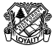
Andergrove State School …. Booklist 2024

To reduce the cost purchasing the most expensive items on a usual class booklist, Andergrove State School offers parents/carers the opportunity to join our Student Resource Scheme. Families who choose to participate in the Student Resource Scheme pay a small levy and only purchase the items listed below (refer Student Resource Scheme information).

Book and Stationery Requirements | Prep | Yr 1 | Yr 2 | Yr 3 | Yr 4 | Yr 5 | Yr 6
A4 Paper - (reams) | 3 | 2 | 2 | 2 | 2 | 2 | 2
Biro (Red) |  |  |  |  |  | 2 | 2
Biro (Blue) |  |  |  |  |  |  | 2
Botany Books |  | 2 | 2
Crayola Thick Textas | 1
Coloured Pencils (1 box) (Staedtler Brand recommended) | 2 | 2 | 2 | 2 | 2 | 1 | 1
Crayons (box 12) (Windups) | 2 | 2 | 2
Display Folders (clear front) | 2 | 3 | 3 | 3 | 3 | 2 | 2
Exercise Books – A4 (48 pages) Red & Blue Lines |  | 8  (Ruling A) | 10  (Ruling B) | 12  (Ruling C) | 12  (Ruling C)
Exercise Books - A4 (96 pages) Ruling D – Blue Lines |  |  |  |  |  | 10 | 10
Felt Pens |  |  |  | 1 | 1 |  | 1
Folder (Clipboard) |  |  |  |  |  | 1 | 1
Glue Stick (Bostick) Large | 2 | 6 | 6 | 5 | 5 | 4 | 4
Clag Glue – large bottle (red label) | 3
Document Wallets (CARDBOARD ONLY) | 2 |  |  | 2 | 2
Graph/Grid/Quad Book – A4 (Years 1- 5 = 10mm) |  | 1 | 1 | 3 | 3 | 3 | 2
Headphones- ear plug variety that are compatible with an iPad.  *Headphones – overhead variety with a microphone that are compatible with an iPad and computer |  | 1 | *1 | *1 | *1 | *1 | *1
Highlighter Pen (different colours) – Stabilo Boss preferred |  |  | 2 | 4 | 4 | 4 | 4
Library Bag (available Uniform Shop - $10.00, Velcro closing) | 1 | 1 | 1 | 1 | 1 | 1 | 1
Manilla Folder (CARDBOARD ONLY) |  |  |  |  |  | 2 | 2
Masking Tape | 1 | 1 | 1 |  |  | 1 | 1
Pencils (Learner – thick) - Writing | 2
Pencils HB, (Staedtler Brand recommended - 1 box of 12) | 4 pencils only | 2box | 2box | 3box | 3box | 2box | 2box
Pencil Sharpener (metal with container – Staedtler) | 1 | 2 | 2 | 2 | 2 | 2 | 2
Pencil Case – large with zippered front pouch | 1  Able to fit A4 size book | 1  Able to fit A4 size book | 1  Able to fit A4 size book | 1 | 1 | 1 | 1
Pencil Case - small |  | 1 | 1
Recorder (Descant C) |  |  |  | 1 | 1 | 1 | 1
Rubber (soft white) |  | 4 | 4 | 4 | 4 | 4 | 4
Ruler (wooden) |  | 1 | 1 | 2 | 2 | 2 | 2
Scissors (blunt ended, metal blades and plain plastic handles) | 1 | 1 | 1 | 1 | 1 | 1 | 1
Sketchbook Spirax A4 No. 534 |  |  |  |  |  | 1 | 1
Scrapbook 96 page | 3 | 4 | 4 | 2 | 2
Sticky Tape – large rolls | 1 | 1 | 1 | 1 | 1 | 2 | 2
Tissues (box of 200) | 1 | 2 | 2 | 2 | 2 | 2 | 2
/tmp/in/input.doc
-2-
Book and Stationery Requirements…..cont. | Prep | Yr 1 | Yr 2 | Yr 3 | Yr 4 | Yr 5 | Yr 6
Soundwaves Chart | Standard Chart | Standard Chart | Standard Chart | Standard Chart | Extended Chart | Extended Chart | Extended Chart
Clear Plastic Wallet (foolscap) - * 1 used for Music | 1 (Music) | 3* | 3* | 2* | 2* | 3* | 3*
Whiteboard Markers – not permanent (pack of 4)  Faber Castell (black only) | 2 | 2 | 2 | 2 | 2 | 2 | 2
Writing Time – Student Practice Book Qld Fonts |  | Yr 1 | Yr 2 | Yr 3 | Yr 4

LEVY covered Items | Prep | Yr 1 | Yr 2 | Yr 3 | Yr 4 | Yr 5 | Yr 6
Atlas - Jacaranda Primary Atlas | 0 | 0 | 0 | 0 | 0 | 1 | 0
Calculator - Sharp EL231LB | 0 | 0 | 1 | 0 | 1 | 1 | 1
Macquarie Primary Dictionary 4th Edition | 0 | 0 | 0 | 1 | 1 | 1 | 1
Kent Set (Celco Mathematical Instruments) | 0 | 0 | 0 | 0 | 0 | 1 | 1
Writing Time Early Years Dictionary- QLD Beginner’s Alphabet (Firefly publication) | 0 | 1 | 1 | 0 | 0 | 0 | 0
iPad apps/ Website subscriptions
‘Reading Eggs’, Year 4 – “Reading Express” | 0 | 1 | 1 | 1 | 1 | 0 | 0
Mathletics | 0 | 0 | 1 | 1 | 0 | 0 | 0
‘Maths Seeds’ | 0 | 1 | 1 | 0 | 0 | 0 | 0
‘IXL’ Maths | 0 | 0 | 0 | 1 | 1 | 1 | 1
‘Showbie’ icloud storage | 0 | 0 | 0 | 0 | 1 | 1 | 1

ADDITIONAL NOTES:
- Clear plastic wallet (for Music only) – only 1 per child when they start school
- ALL STUDENTS require a broad brimmed hat or bucket hat for outdoor use (no caps). No hat - no shoes - no play.
- Families who choose not to pay the levy must provide all items listed above under ‘Levy covered items’. Refer to the information about the Student Resource Scheme.
- Students in Year 4-6 are encouraged to bring their iPad device and participate in our schools ‘Bring your own device program’. Students who are unable to BYO an iPad device will be offered a school device to share with a number of other students. A screen protector and a hard case are recommended. A list of the apps that need to be pre-loaded by families prior to the start of the school year will be provided. These apps are generally free. Parent support for how to load apps will also be provided.
- Booklist consumables (e.g. glue, pencils, crayons etc.) may need to be replaced regularly throughout the year.
- All items should be clearly labelled with student’s name and year level.
- Books/Pads should be appropriately covered.
- ‘Spare’ books and materials have been requested at this time to allow parents to take advantage of ‘special prices’ on offer at this time of year. “Spares” will be stored at school for use later in the year. Unused resources will be returned at the end of the year.

Pad Rulings: All correct rulings are shown below:

Ruling A  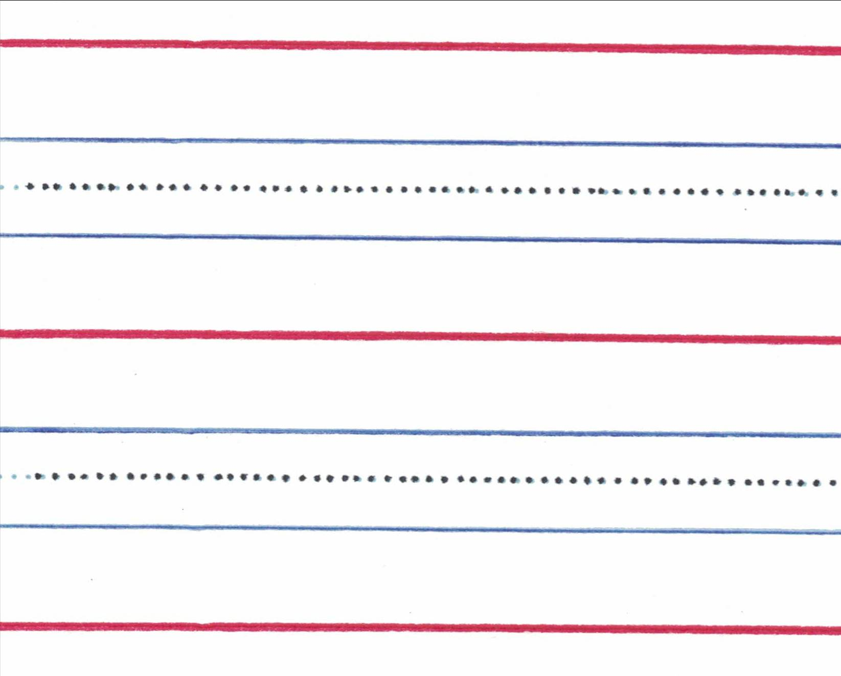 | Ruling B  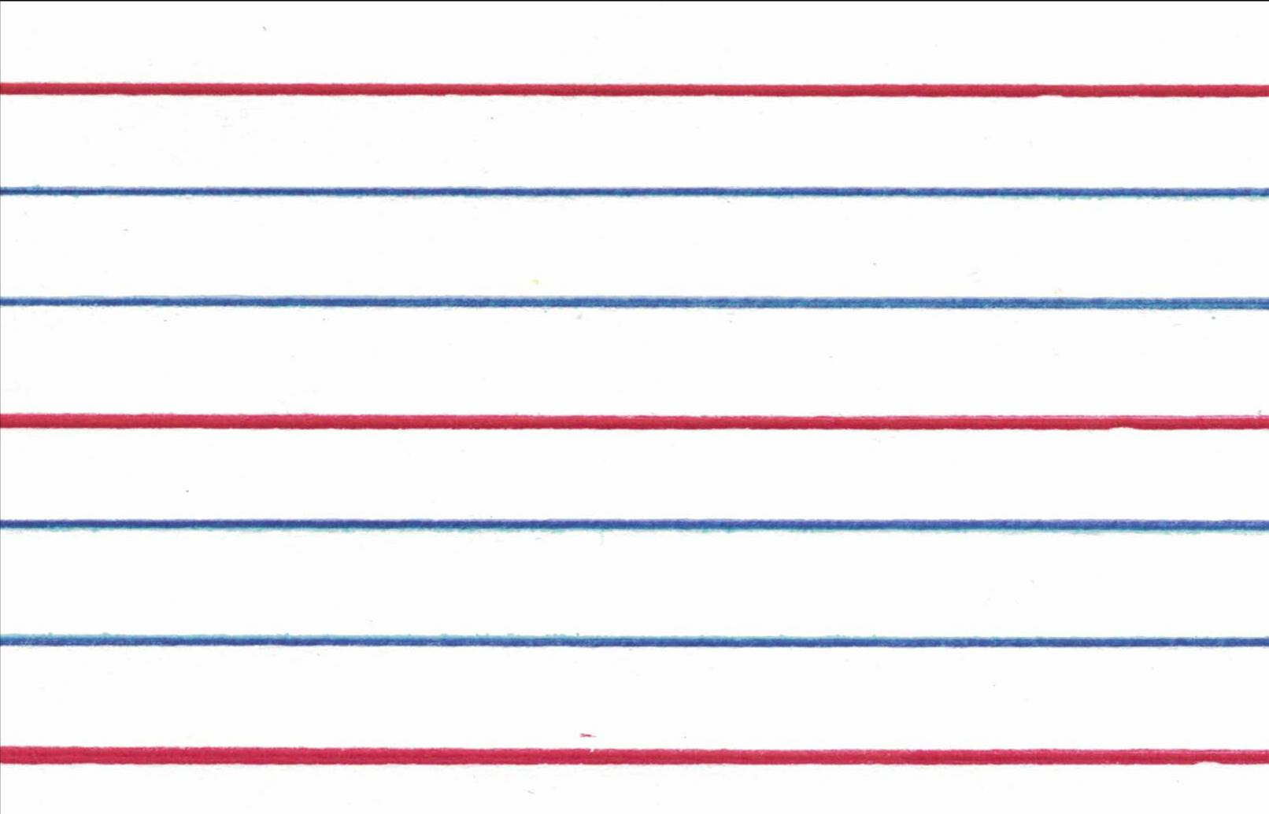 | Ruling C  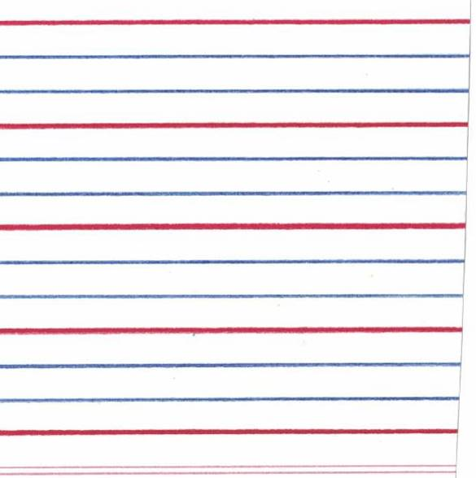
Ruling D   | Graph/Grid/Quad Book Ruling  Yrs 1-5:  